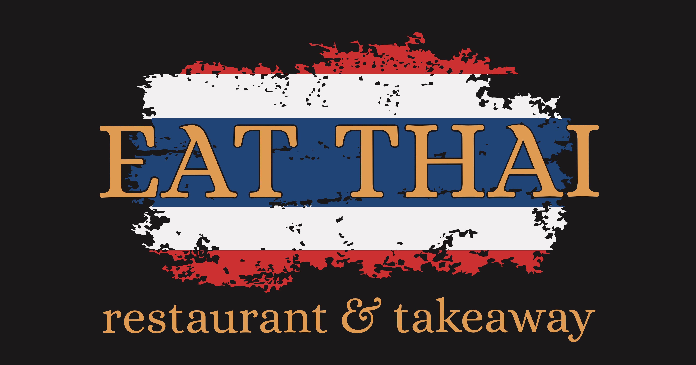


Fully Licensed

Open Everyday

Lunch 12.00 – 3.00 pm

Dinner 5.30 – 10.30 pm Fri – Sat 5.30 – 11.00 pm
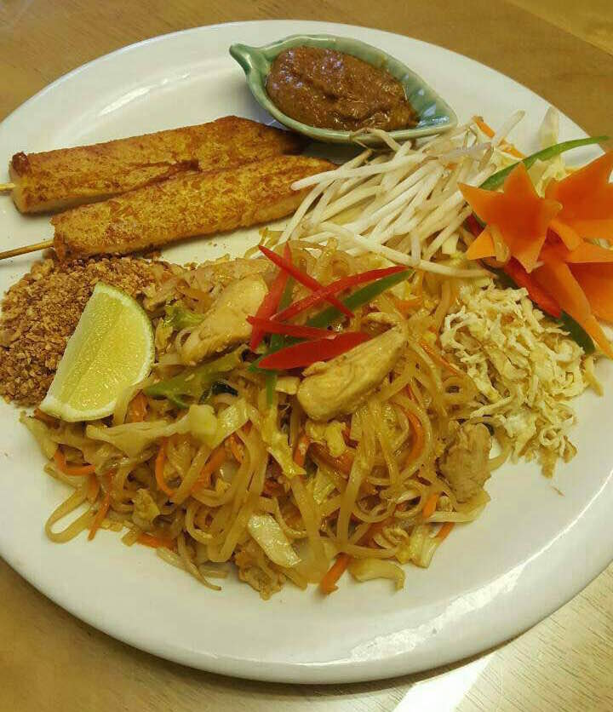
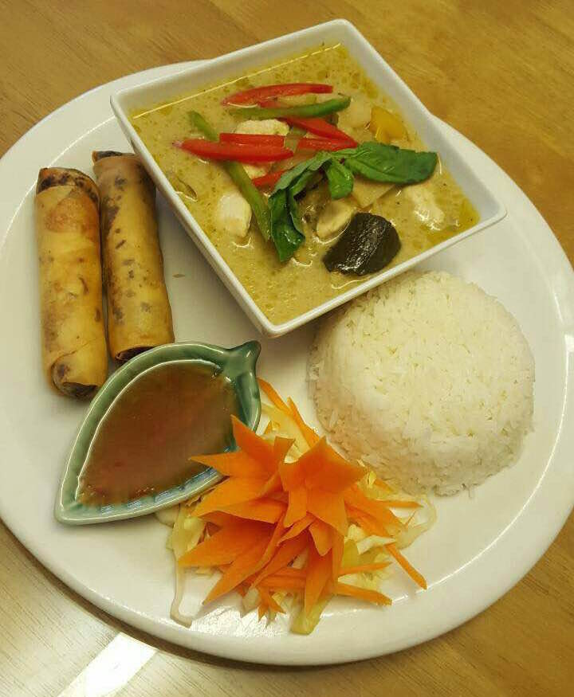

Express Lunch £7.95

(Starter and Main course)

8 St.Marys Street, Ely , CB7 4ES
Tel.01353 969455
www.ely-eatthai.co.uk
E-Mail : ely-eatthai@hotmail.com
------------------ Please Note ------------------
All Credit/Debit Cards are accepted on
payment over £15.00
*10% Service Charge will be added on the party of 6 people or more*

Starters
1.Mixed Starter (Minimum 2 people) Per Person 6.35
Special mixed starter with poh pia tord, Fish cakes,
Prawn Toasts, Dim Sum, Kai Sateh served with peanut
and sweet chilli sauce.
2. Prawn Cracker 3.00
3. Dim-Sum 4.95
Dumplings made of chicken, prawns Topped with garlic
4. Poh Pia Tord (V) 4.55
Deep fried vegetable spring rolls Served with sweet chilli sauce.
5. Poh Pia Ped 4.95
Deep fried duck spring rolls served with hoi sin sauce.
6. Kiaw Krob 4.95
Crispy fried wonton with minced chicken and prawns
Served with sweet chilli sauce.
7. Tod Mon Pla 4.95

Deep fried Thai style fish cake with spices
and red curry paste, Served with sweet chilli sauce and peanut
8. Peek Kai Tod 4.95

Deep fried battered chicken wings with sweet and sour sauce
9. Royal Thai Dumpling 5.25

Steamed dumpling with sweet chicken & nuts stuffing
11. Kha Nhom Phang Nah Goong 4.95
Mixed chicken and prawns on toast served with sweet chilli sauce.
12. Se Krong Moo Ob 5.75
Pork spare rips marinated in Honey sauce.
13. Kai Sateh 4.95

Strips of chicken marinated in Thai spice, on a stick
grilled over charcoal and served with a peanut sauce.
14. Moo ping 5.25
Strips of pork marinated in Thai spice, on a stick grilled.
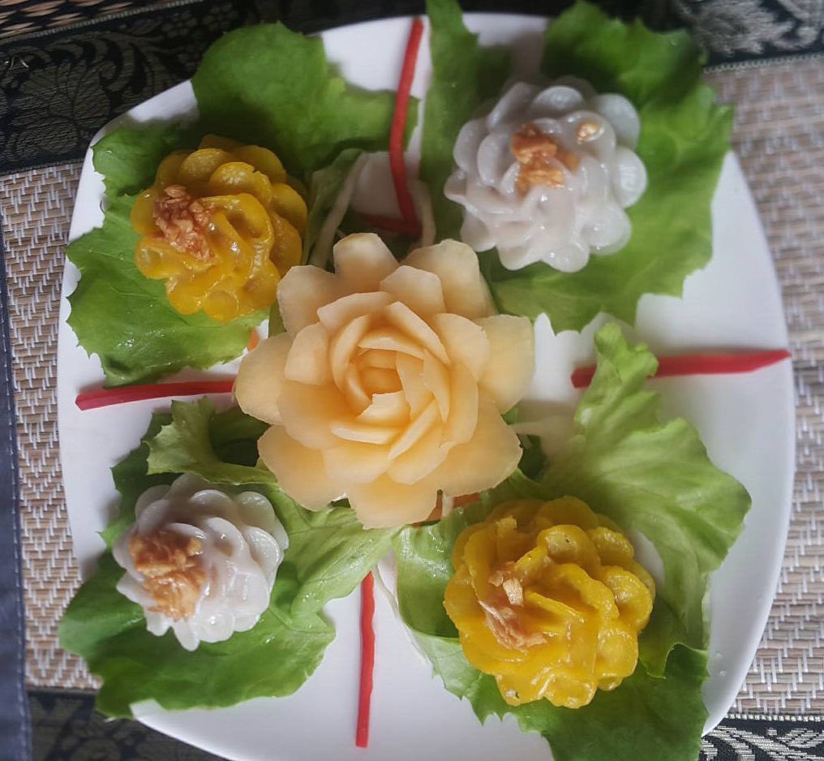
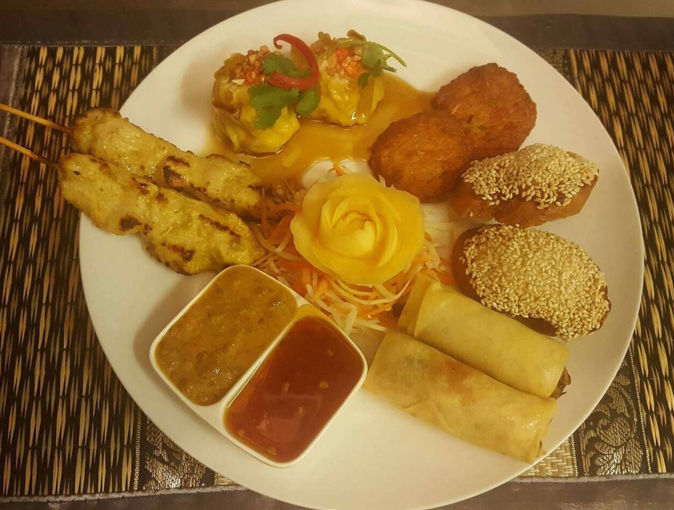

1
9
16.Salt & Pepper Squid 5.75

Deep fried squids in batter
17. Prawn Tempura 5.75
Deep fried marinated prawns in light batter served plum sauce.
18. Vegetable Tempura (V) 4.55
Deep fried vegetable in batter Served with plum sauce.
19. Tao Hu Tord (Crispy Tofu) (V) 4.55

Crispy tofu Served with sweet chilli sauce and peanut
20. Deep Fried Crispy Beef Shreds 5.25

21. Crispy Duck
Aromatic crispy duck served with Quarter 8.95
Pancakes, cucumber, spring onions Half 15.95
carrot and hoi sin sauce. Whole 27.95

Soups
22. Tom Yam 
The classic Thai hot and sour soup Mushrooms 4.55
with lemon grass, lime leaves and Chicken 4.95
mushrooms. Prawns 5.95
23. Tom Kha
Thai coconut milk soup with Mushrooms 4.55
lemon grass, lime leaves, galangal Chicken 4.95
and mushrooms. Prawns 5.95

Curry Dishes
Please Choose the dishes and then choose the meat
Vegetables 7.65 Tofu 8.15
Chicken/Beef/Pork 8.65 Duck 9.15 Prawns 9.65
24. Gang Kiew Wan
Green curry paste with coconut milk, vegetable and Thai herbs.

25. Gang Dang
Red Curry paste with coconut milk, vegetable and Thai herbs.

26. Gang Kari
A mid yellow curry in coconut milk, onion and potatoes.

27. Gang Massaman
This is a popular dish from south of Thailand is a slowly
braised meat curry in coconut milk, peanut, onion and potatoes.

28. Gang Panang
panang curry paste with coconut milk and lime leaves

29. Gang Ped Yang (9.65)
Red spicy duck curry with coconut milk, pineapple and
tomatoes.

30. Gang Pha
A hot and spicy jungle style curry cooked with vegetable and
Thai herbs

Stir Fried Dishes
Please Choose the dishes and then choose the meat
Vegetables 7.35 Tofu 7.85
Chicken/Beef/Pork 8.35 Duck 8.85 Prawns 9.35
31. Pad Ga Prao
Stir fried with chilli, vegetable and basil leaves.

32. Pad King
Stir fried with ginger and vegetables.

33. Pad Priew Wan
Stir fried with vegetables in sweet and sour sauce.

34. Pad Nam Mun Hoi
Stir fried with vegetables and oyster sauce.

35. Pad Med Ma Moung
Stir fried with vegetable and cashew nut.

36. Stir Fried Black Bean Sauce
Stir fried with vegetable in black bean sauce

Salads
37. Larb (Chicken/Minced Pork) 9.15

Spicy minced pork or chicken salad flavoured
with roasted ground rice and fresh herbs.
38. Yum Ruam mid 11.95
Thai famous mixed seafood with chilli, lemon grass
and vegetables
39.Som Tum (V) 7.25
Carrot salad, seasoned with fresh lemon juice dressing,
Crushed garlic, chilli, tomatoes and long beans.

Fish Dishes
40. Pla Chu-Chi  12.45
Fresh crispy cod fish in red curry paste in coconut milk
With sweet Thai basil and lime leaves.
41. Pla Rad Prig 12.45
Deep fried crispy cod fish topped with a spicy Thai sauce.
42. Pla Ma Kham 12.45
Deep fried crispy cod fish in sweet and sour tamarind sauce.

Chefs Special Dishes
43. Gai Yang 13.45
Grilled marinated chicken with Thai herbs served on a hot
Sizzling platter with sweet chilli sauce.
44. Gai Manao 12.45
Tempura battered chicken covered in a sweet lemon
and chilli sauce dressed with slices of lemon and coriander.
45. Weeping Tiger 14.95
Grilled Sirloin steak marinated with Thai herbs served on

A hot sizzling platter with spicy sauce
46. Moo Dang Ob Nam Pueng 13.65
Thai style marinated fillet of pork in honey sauce.
47. Ped Ob Nam Pueng 13.95
Sliced Duck breast marinated in honey sauce.
48. Panang Ped Tod 13.95 Crispy marinated duck breast with aromatic thick
panang curry cream sauce.
49. Ped Ma Kham 13.95
Sliced duck breast marinated in sweet and sour tamarind sauce.
50. Goong Ma Kham 14.95
Deep fried marinated prawns in sweet and sour tamarind sauce.

51. Pla Salmon Priew Wan 13.95
Deep fried crispy salmon with crunchy vegetables in
sweet and sour sauce.
52. Pla Manao 15.15
Steamed whole sea-bass fillet fish in lemon sauce with
freshly ground chilli topped with celery, red chilli,
garlic and spring onion.
53. Pla Nung Siu 15.15
Steamed whole sea-bass fillet fish with ginger and vegetable
in soya sauce.
54. Ho Mok Talay 14.55
Basket of mixed seafood with red Thai curry,
Sweet basil, lime leaves topped with slices of red chilli.
55. Goong Pao 16.95
Char-grilled giant king prawn marinated with Thai herbs
served on a hot platter with spicy seafood sauce.

56. Sizzling Prik Thai Dum
(with Beef/Pork 12.95, Seafood 14.55)
Stir fried with vegetables in chilli and black pepper sauce
served on a hot sizzling platter

Rice and Noodles
Please Choose the dishes and then choose the meat
Vegetables 7.35 Tofu 7.85
Chicken/Beef/Pork 8.35 Duck 8.85 Prawns 9.35
57. Pad Thai
Stir fried rice noodle in Thai style with vegetables and
topped with ground peanuts.

58. Pad Siew
Stir fried rice noodle in soya sauce, egg and vegetables.

59. Pad Kee Mao (Spicy Noodles)
Stir fried rice noodle with chilli, egg and vegetables
in dark soya sauce.

60. Spicy Udon Noodle
Spicy thick japanese noodle with vegetables.

61. Chowmein Noodle
Stir fried egg noodle with egg and vegetables.

62. Singapore Noodle
Stir fried rice vermicelli noodle with chilli, egg and vegetables.

63. Special Fried Rice
Fried rice with egg and vegetable in soya sauce

64. Khao Suey (V) 2.50
Steamed Thai jasmine rice.
65. Khao Pad (V) 3.00
Fried rice with egg.
66. Khao Kra Ti (V) 3.00
Thai jasmine rice cooked with coconut milk.
67. Khao Neaw (V) 3.00
Thai Sticky rice.
68. Plain noodle (V) 3.00
Plain egg noodles.

Vegtarian Dishes
69. Pad Pak Ruam (V) 7.35
Stir fried mixed Vegetables in soya sauce.
70. Tao Hu Pad Priew Wan (V) 7.85
Stir fried Tofu, vegetables in sweet and sour sauce.
71. Tao Hu Pad Khing (V) 7.85
Stir fried Tofu with ginger and vegetables in soya sauce.
72.Tao Hu Med Ma Moung (V) 8.15
Stir fried Tofu with vegetable and cashew nuts in soya sauce.

Special Set Menus

Bangkok Set
£27.95 per person (minimum 2 people)

Starter
Mixed Starter with Poh Pia Tord, Fish cake, Prawns Toast, Dim-sum and Kai Satay served with chilli and peanut sauce.

Main Courses
Gang Kiew Wan Gai (Green Chicken Curry.)
Sizzling Seafood (Marinated mixed seafood stir fried with vegetables in chilli and black pepper sauce.)
Pla Ma Kham (Crispy cod fish in sweet and sour tamarind sauce.)
Pad Pak Ruam (Stir fried mixed vegetable)
Khao Pad (Egg fried rice)

Coffee or Tea

Phuket Set
£24.95 per person (minimum 2 people)

Starter
Mixed Starter with Poh Pia Tord, Fish cake, Prawns Toast, Dim-sum and Kai Satay served with chilli and peanut sauce.

Main Courses
Gang Massaman Beef (meat curry in coconut milk, peanut, onion and potatoes.)
Sizzling Pork (Stir fried pork with mixed vegetables in black pepper sauce )
Duck Pad Med Ma Moung (Stir fried duck with mixed vegetables and cashew nut )
Pad Pak Ruam (Stir fried mixed vegetable)
Khao Pad (Egg fried rice)

Coffee or Tea

Set Vegetarian

£21.95 per person (minimum 2 people)

Starter

Vegetarian Mixed Starters

Main Courses
Gang Dang (Red Vegetables Curry)
Tao Hu Pad Khing (Stir fried Tofu with ginger and vegetables)
Pad Priew Wan(Stir fried mixed vegetable in sweet & sour sauce)
Pad Pak Ruam (Stir fried mixed vegetable in soya sauce)
Khao Pad (Egg fried rice)

Coffee or Tea

--------------------------- MILD-MEDIUM

------------------------- MEDIUM-HOT
V ---------------------------- VEGETARIAN
----------------------- MAY CONTAIN SMALL BONES

We cannot accept responsibility for person with any food allergies as our dishes can contain wheat products, GM products and traces of nut.

